NCL 2020 Individual Game

|  |
| --- |
| * This is an individual or group assignment, and worth 30 points. * The individual game ends on Sunday, October 25, 2020 21:00. * Follow the usual naming convention. * Make screenshots readable. |

# Game outcome

* Individuals: a total completion rate of min 30% (min 10% per category)
* Groups: min 50% in combination (min 15% per category)

**Screenshot #1**

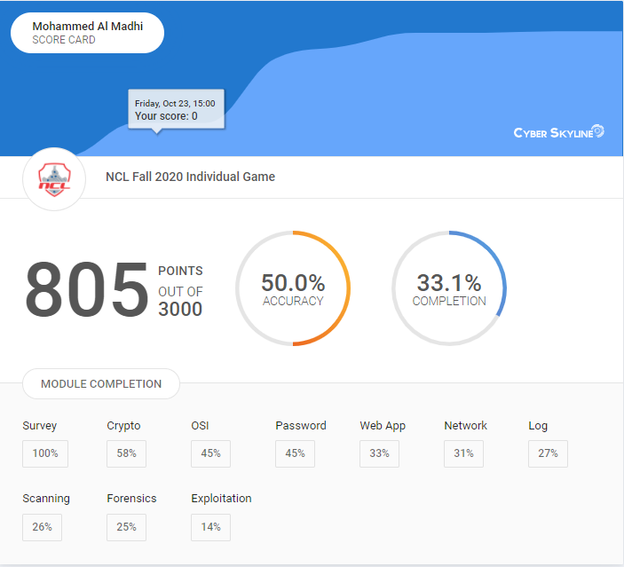

**Screenshot #2**

